


Adviser Evolution
IS Messaging
MMC Snap in User Guide
Version: 1.0.

Table of Contents
1 Introduction 4
1.1 Overview 4
1.2 Pre-requisites 4
1.3 Compatibility 4
2 Getting Started 5
2.1 Setting up MMC 5
3 Managing the Service 10
3.1 Host Service Configuration 10
3.2 Starting/Stopping the Service 10
3.3 The Summary display 11
3.4 The Health Display 18
4 Appendix 1 – Host Service Configuration 23
5 Appendix 2 – Snap in Client configuration 25

Change Control History

Version | Author | Date | Details
1.0 | Tony Capps | 16/7/2007 | First version

All Intellectual Property Rights are and shall remain the property of Independent Specialist Technology (UK) Ltd unless otherwise stated.

Introduction

Overview
This document describes the use of an MMC (Microsoft Management Console) Snap in to manage the 1st Integration Services (IS) Messaging system. This represents a considerable improvement over the earlier piecemeal approach to the problem, in that it provides a single point to examine system status, view and edit the configuration, and start and stop the various services involved. A graphical view of the system is included with a ‘traffic light’ approach to representing system status and problem identification.
A significant improvement is the ability to monitor the system remotely. In order for this to work, the client machine running the console must have http access to the target server(s), over a range of ports (these are configurable). Currently, some aspects of the functionality is limited in this mode (for example re-posting failed messages to a remote transactional message queue is not available). These issues do not prevent the monitoring from working, as appropriate warning messages are generated. It is hoped to circumvent these restrictions in the future.
The current version is very much a version 1, and is a work in progress. Some functions are not implemented (for example Statistics from some of the services). Work will continue on these and other improvements (such as better configuration support).

Pre-requisites
The Snap in component requires MMC version 3.0 to be installed. This will be already be present in systems running Windows Server 2003 R2, and Windows Vista. Other environments (e.g. XP) can download the required update from: http://support.microsoft.com/kb/907265

Compatibility
The new Management Snap in is fully compatible with the existing Services, and can co-exist. However, in order to provide the control required, the services now run in a new Integration Services Host Service, and the existing services are no longer used (although they can remain as a backup if required). If they are retained, it is recommended that they are disabled in order to prevent accidental running of two competing processes.
This new architecture significantly increases manageability as at the Windows level only one service is used instead of five.
The Snap in does not monitor or manage the 1st Scheduler service, although this may be added in the future.

Getting Started
It is assumed at this point that the requisite installs have completed:
- Messaging Server Install including the new Hosting Service, and server side components.
- MMC Snap in client code (on the machine begin used for monitoring)

Setting up MMC
The first step is to run the Management Console, Click on File -> Add/Remove Snap-in
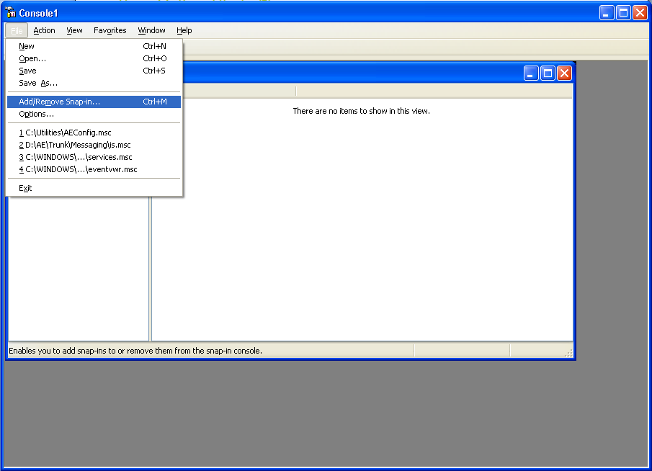
In the dialog that is shown, click on ‘Add’.
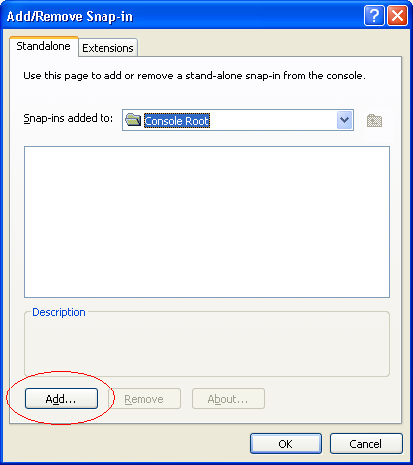
In the list that then gets displayed, locate and highlight ‘IS Management’:
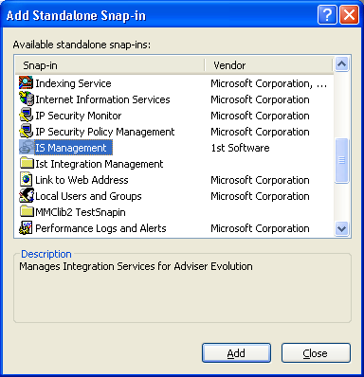
Click on ‘Add’ and then ‘Close’. The click on ‘OK’ in the Add/Remove Snap in Dialog. You should now see the following in MMC:
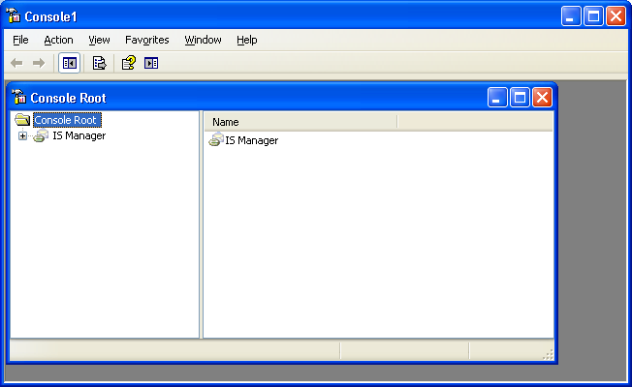
You now need to set up the remote machines you are monitoring. It is important to note that you can monitor more than one machine from the same snap in.
Select the ‘IS Manager’ node, and then Right click and choose ‘Add Installation’:
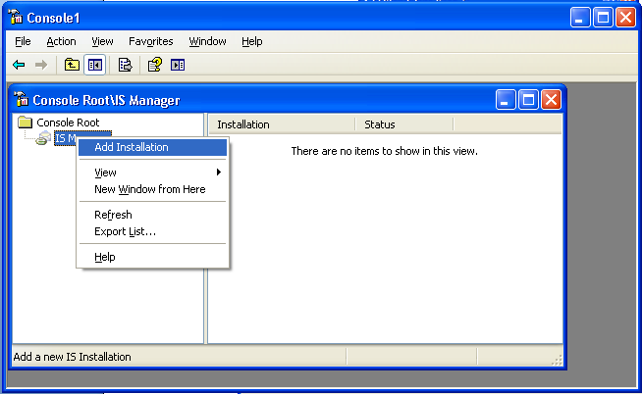
In the resultant Dialog Box, enter a relevant name (e.g. Wesleyan) and click on OK.
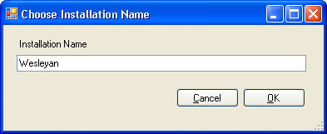
Expand the IS Manager node to show your new Installation, select it, and right click again to choose ‘Add Server’:
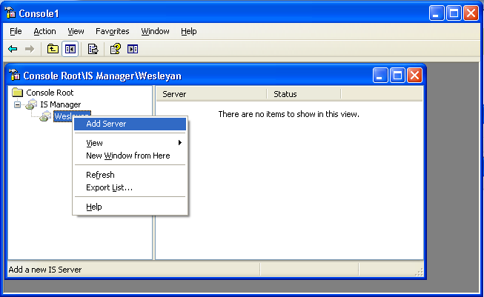
Now enter the Display name, and Network name for the server you wish to monitor and click on OK.
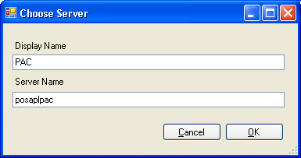
The setup is now complete, and you can click on the new Server node to see its status:
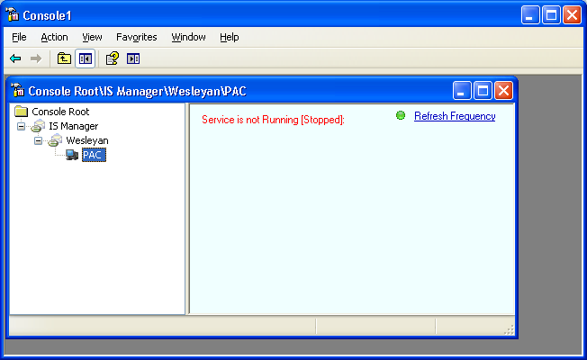
You can add another Server into the Installation if required (e.g. the ACC environment) and use the one snap in to manage both environments.

Saving your MMC settings
You can save your setup by clicking on the ‘File’ menu and choosing ‘Save As’. The state is saved into an ‘.msc’ file (which is the default extension for MMC). Subsequently you load this by choosing File/Open and selecting this file, or by opening the file directly as ‘.msc ‘extensions are associated with MMC.

Managing the Service

Host Service Configuration
The new Host service is configured during the install, and should not require subsequent modification. This configuration identifies which services to load, and where they are located on the server. It also identifies the relevant configuration files along with the http port numbers used to communicate with the snap in. If these port numbers are changed on the server, the same changes must be applied to the local snap in configuration to match. If this is not done, then the snap in will be unable to communicate with the server. The Service and Snap in configuration files can be seen in the Appendices.

Starting/Stopping the Service
The host service can be started and stopped remotely using the snap in. Right click on the Server node, and select Start or Stop.
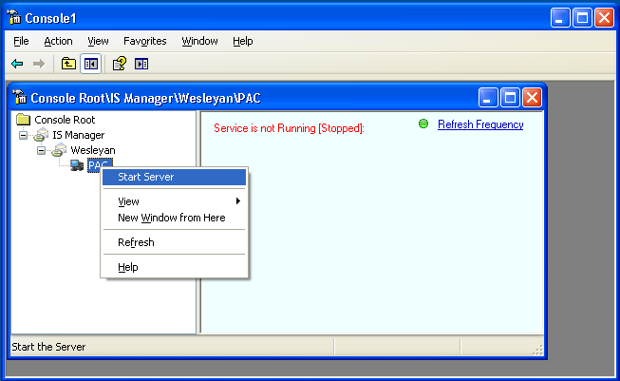
Note: The commands displayed in the menu are context sensitive, relating to the state of the service (i.e. it shows ‘Start’ only if the service is stopped, and vice versa). However, there is a bug in Microsoft’s MMC whereby this check only gets actioned when the node is selected and it is therefore possible to see ‘Start Service’ when it is already started. This is easy to rectify by clicking another node, and back again. Work will continue to work around this.

The service will now start, and the display will change to:
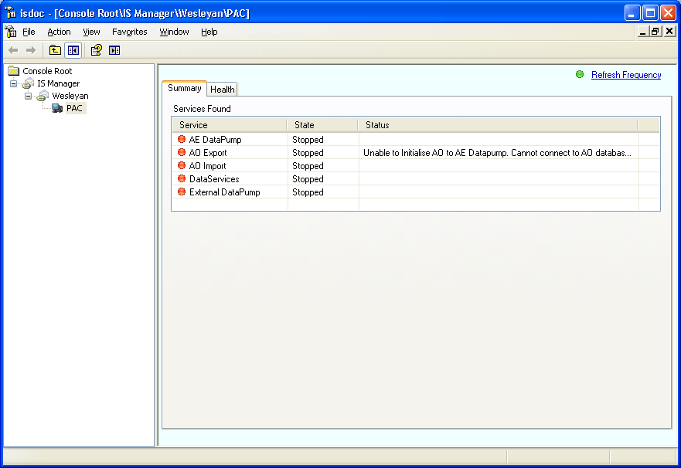
Note: This section shows a number of deliberate problems to highlight the capabilities of the console. In this example, the first problem can be seen above whereby no connection can be made to the AO database by the AO Export service.
The service can be stopped in the same way.

Refresh Frequency
The Running service is queried periodically for its state information, and this period defaults to 1 second. You can change this by clicking on the ‘Refresh Frequency’ link at the top of the display. The Icon next to it will change to red whenever data is being exchanged with the server. This serves as a visual ‘heartbeat’ verifying correct operation.

The Summary display
The screen above shows the basic summary display, where the configured services are displayed along with their individual status. The Host Service configuration data can specify whether these services are started automatically or not. By default they are not. If it is required to change this, then the file must be edited manually at the moment.
Each service supports a Menu, accessed by right clicking on the service name:
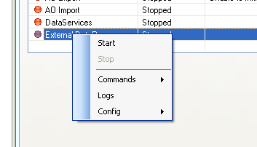
The menu is the same for all the services, although the available options will depend on the current context of the service. The basic items are:
Start Start the service
Stop Stop the Service
Commands Access a sub menu of commands if supported by the service.
Logs Display any Event Log entries from the target server relevant to this service,
Config Access any configuration information used by that service. This allows remote modification of configuration information.
Each is now described in more detail.

Start
Use this to start the (sub) service. This is the equivalent of starting the Windows Service before. It is usually quicker however, as the modules are already loaded. When completed, the indicator changes to green for that service to indicate a running state. In addition, statistics output by the service are displayed in the panel beneath the service list.
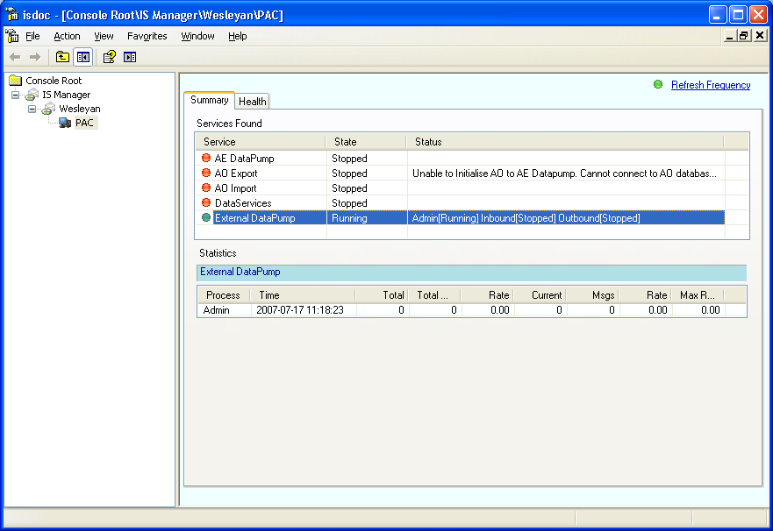
Note: Currently only External DataPump and Data Services support statistics.
This figure shows the External DataPump started, with the statistics pane below. The service has only started the ‘Admin’ process and this is reflected in the Status for that service, and the fact that statistics only show the ‘Admin’ line. To start the other processes use the Relevant ’Commands’ available (see below).

Stop
Use this to stop the (sub) service. Any statistics displayed for the service will disappear, and the indicator should change to red.

Commands
This option will display any commands that the selected service supports. If there are none, then this option will be greyed out and unavailable.
The following commands are supported for the above example:
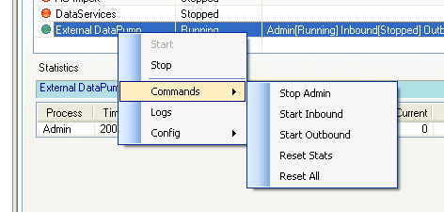
These commands are context sensitive, and can change depending on the state of the service. In this example, you can start/stop the various processes as well as reset the statistics. For example choosing ‘Start Outbound’ will start that process and you will see an extra line in the statistics display.
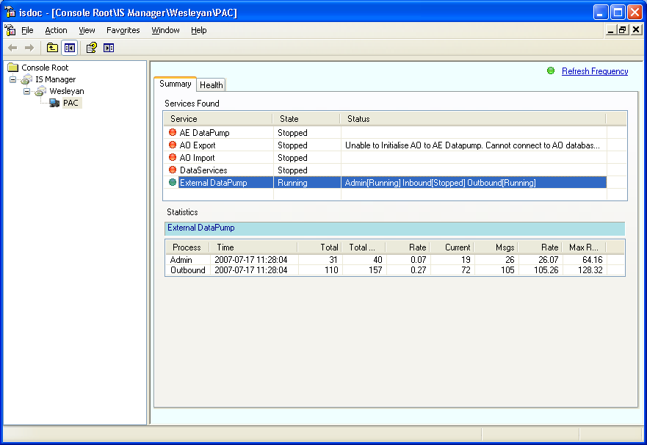

Logs
This displays a summary of all Event Log messages (from the target Server) relevant to the selected service. The display is a snapshot taken at the time the command is executed, and is not updated dynamically.
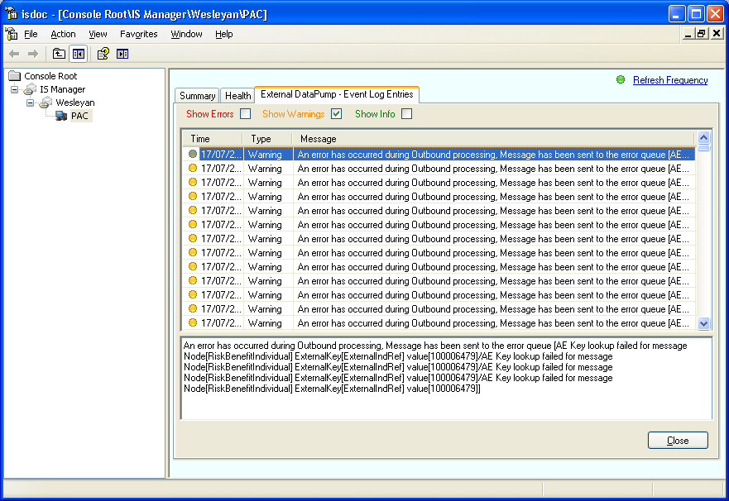
The display is shown in an additional tab that is added to the ones already present. Clicking on ‘Close’ will close that tab.
You can filter the entries by category (Error, Warning, and Info).
Clicking on an entry will display the detail in the bottom pane.

Config
Here it is possible to change the configuration for the selected service remotely. In the case of External DataPump, there are two options:
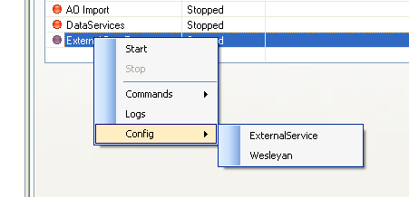
ExternalService allows changes to the generic service setup, and Wesleyan for the Wesleyan specific implementation details.
Clicking on ExternalService will display a bespoke set of dialogs (this is a facility within the snapin that has been implemented here). Most configurations, however, are simple xml files and the snap in supports a simple generic xml editor which caters for most requirements).
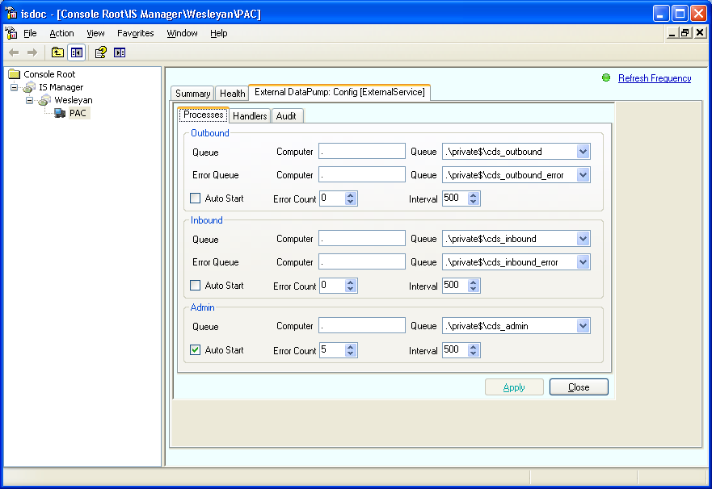
Similar to the ‘Logs’ display, the config screens are shown in a new tab. This one has three sub-tabs to navigate through all the various requirements. Clicking on ‘Apply’ will apply the changes to the server. ‘Close’ will close the tab without updating.
Clicking on the ‘Wesleyan’ option brings up the generic xml editor:
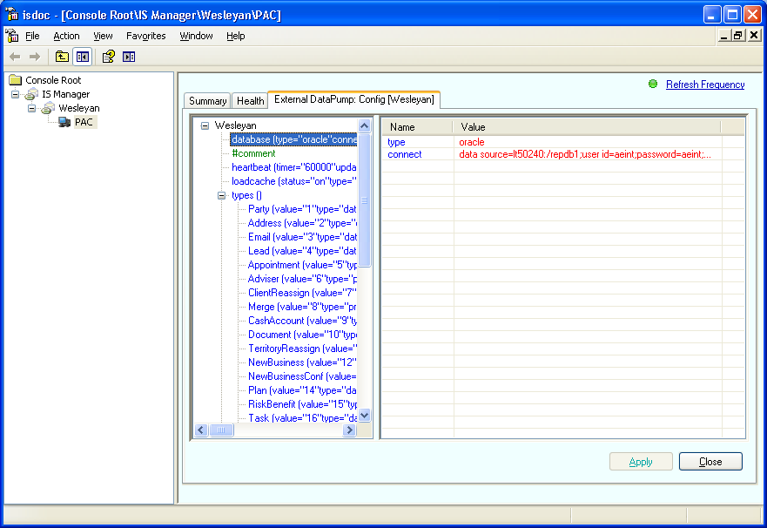
All IS configuration is achieved using xml attributes. These are displayed on detail on the right. If you need to change one double click on the attribute, and you will see the edit dialog:
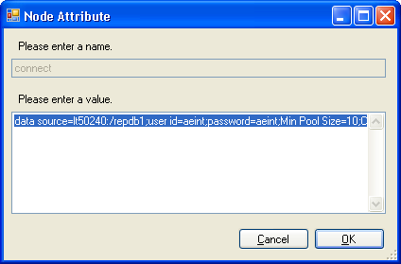
In addition, using right-click will give you the options to ‘Add’, Edit’, or ‘Remove’ an attribute:
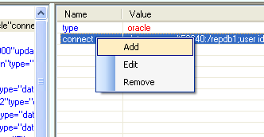
Again, clicking on Apply will update the configuration on the server, and ‘Close’ will simply close the tab.
Note: When applying changes you will get a confirmation that the changes have been applied:
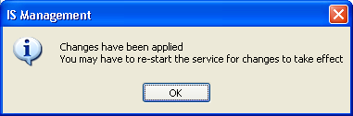
At present this means the Host Service, not the individual hosted services. This is because configuration files are loaded regardless of whether the (sub) service is actually running. It is planned to change this in the future to support dynamic updates

The Health Display
This screen is a graphical representation of all the components required in the messaging environment. Each node represents one of three types:
- A Database
- A Service
- A message queue
Each node has a status, which is represented by a graphic and gives a very quick indication of problems. In general, green ticks are good, red crosses are bad. Most problems can be corrected from the snap in, but some may require intervention on the server. In time it is hoped to increase the facilities available so that direct intervention will rarely be required.

Databases
Database nodes are represented by the icon;
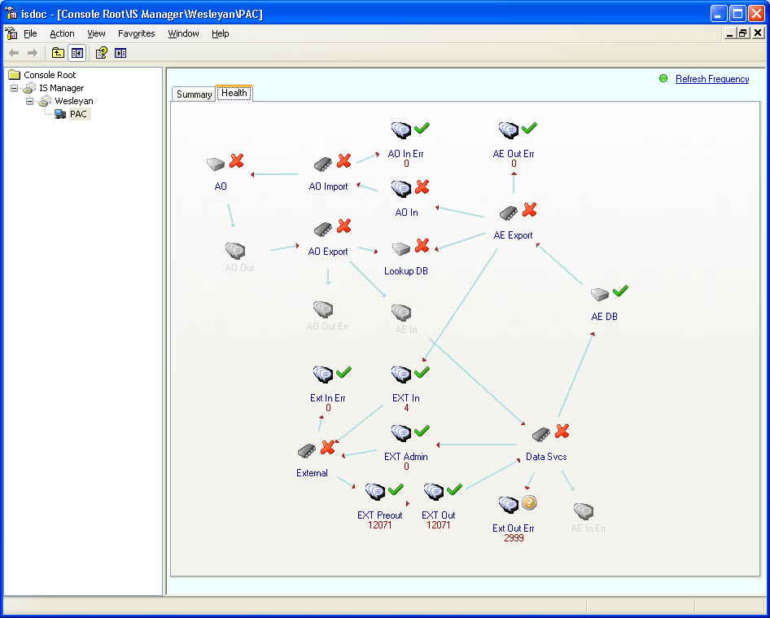
Moving the cursor over a Database node will show the connection details (if all is OK) or problems (if not). If the database is an AE database, then more information is given:
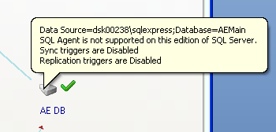
This display above shows a system in a pretty bad state. To investigate a problem, move the mouse cursor over the node with a red cross, and a tooltip will pop up with the reason:
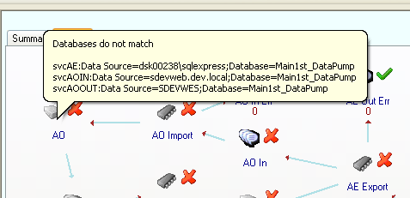
In this example, it is saying that the configuration for the various services do not tally for the AO database. It is easy to use the configuration command to correct the problem. This requires a correction to the configuration for the relevant service.

Services
Services are represented by the icon. A red cross against a Service usually indicates that the service is stopped.
To fix the problem above, and change the configuration for a service, right click on the relevant service node:
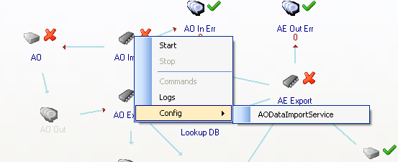
As can be seen, the menus available for services in the Summary Display are also available from the Health Display

Queues
Moving the cursor over a Queue node (identified by the icon) the tooltip will show the Format Name of the queue. If there are any problems with configuration, there will be a red cross, and the reasons will be shown (usually mismatched configurations). The Queue nodes also display the current number of messages in the queue:
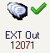
If this is an error queue, the tick will be an Amber question mark, and the message will show that there are error messages:
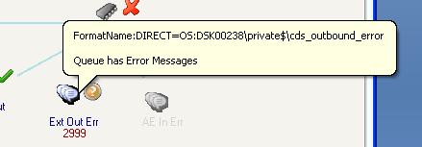
Right clicking on a queue node will show a menu, currently with only one item, ‘View Entries’:
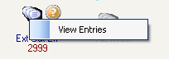
Clicking on this will create a new tab (in the same way as the ‘Logs’ command) to show the messages in the queue:
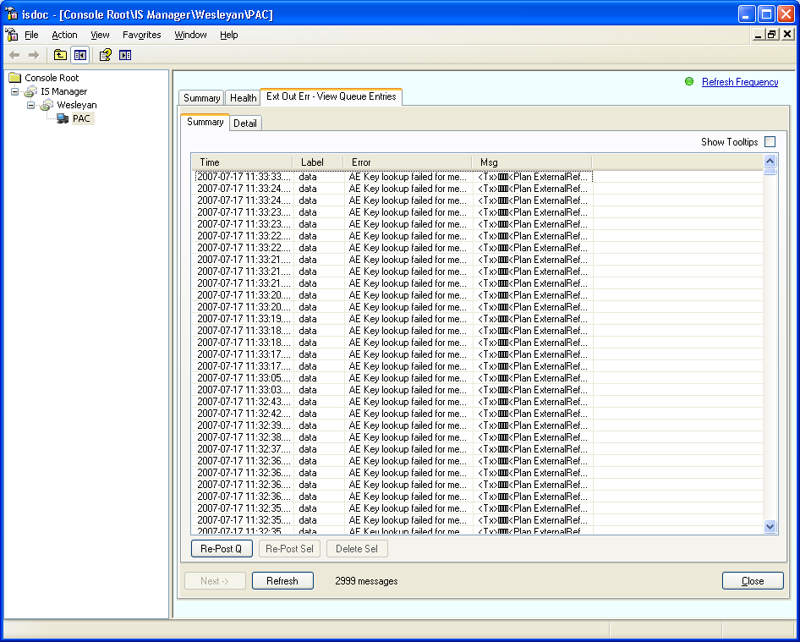
The buttons can be used to batch process these entries by either:
- Re-posting the entire queue for re-processing
- Re-posting the selected lines
- Deleting the selected lines
Note: The list will only show a maximum of 25000 messages in one go. If there are more, the ‘Next’ button will be enabled and this will load the next 25000 in. Clicking ‘Refresh’ will load the first 25000 again.
If you select ‘Show Tooltips’, then moving the cursor over an entry will display in a tooltip the contents of the entry and column the cursor is over. This can be used for a quick investigation of message contents.
Selecting an entry in this list and choosing the ‘Detail’ tab (or double clicking it), will show the message contents:
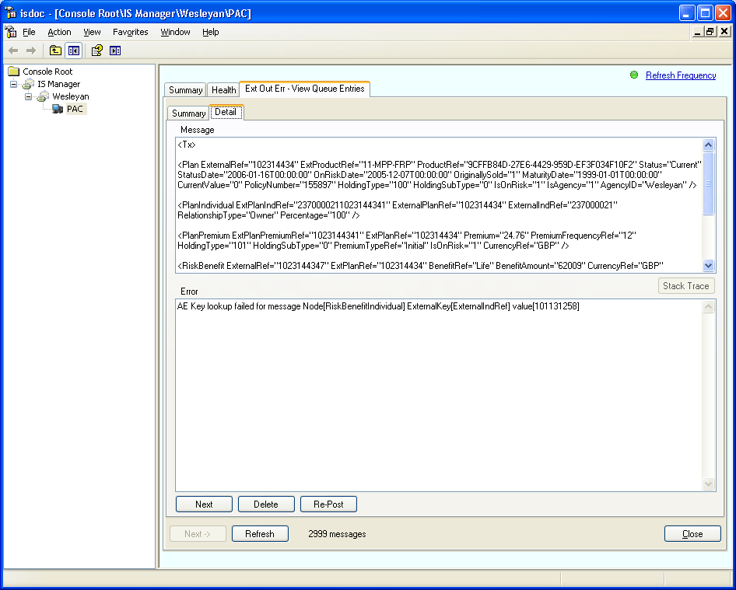
It is possible to edit the message here if necessary, and repost it using the ‘Re-Post’ button. It can be deleted using the ‘Delete’ button.
‘Next’ will show the next message in the list.
Note: If it is not possible to re-post the messages (because of queue location, as explained earlier), then the relevant buttons will be disabled. You will also get a warning message when first displaying this tab.
Clicking on ‘Close’ will close the tab.

Appendix 1 – Host Service Configuration
File name – IS_Service.exe.config
<?xml version="1.0" encoding="utf-8" ?>
<configuration>
<configSections>
<section name="Services"
type="System.Configuration.IgnoreSectionHandler,
System, Version=1.0.3300.0, Culture=neutral,
PublicKeyToken=b77a5c561934e089" />
</configSections>
<appSettings>
<add key="PortLow" value="8090"/>
<add key="PortHigh" value="8099"/>
</appSettings>
<Services>

<Service name="External DataPump"
class="ExternalService.ServiceMain"
assembly="ExternalService"
path="D:\Ae\Trunk\Messaging\ExternalMessaging\Runnable"
autostart="no">
<Config name="ExternalService" file="ExternalMessaging.config"/>
<Config name="Wesleyan" file="Wesleyan.config"/>
</Service>

<Service name="DataServices"
class="DataServicesService.ServiceMain"
assembly="DataServicesService"
path="D:\Ae\Trunk\Messaging\DataServices\Runnable\Server"
autostart="no">
<Config name="DataServices" regkey="SOFTWARE\1st\DataServices" value="ConnectionString"/>
<Config name="AOFeed" file="AdviserEvolutionFeed.dll.config"/>
<Config name="View Audit" regkey="SOFTWARE\1st\DataServices" value="ConnectionString"/>
</Service>

<Service name="AE DataPump"
class="AEMessagingService.ServiceMain"
assembly="AEMessagingService"
path="D:\AE\Trunk\Messaging\AEMessaging\Runnable"
autostart="no">
<Config name="AEMessagingService" file="ISAEDataPumpPlugin.dll.config"/>
<Config name="ExternalConsumer" file="ExternalConsumer.dll.config"/>
<Config name="AdviserOfficeConsumer" file="AdviserOfficeConsumer.dll.config"/>
<Config name="Subscribers" file="ISSubscribers.xml"/>
</Service>

<Service name="AO Import"
class="AOImportService.ServiceMain"
assembly="AOImportService"
path="D:\AE\Trunk\Messaging\AODataImportServices\Runnable"
autostart="no">
<Config name="AODataImportService" file="AODataImportPluginConfig.xml"/>
</Service>

<Service name="AO Export"
class="AOExportService.ServiceMain"
assembly="AOExportService"
path="D:\AE\Trunk\Messaging\AOAEDataPump\Runnable"
autostart="no">
<Config name="AOAEDatapump" file="AOAEDatapumpPlugin.dll.config"/>
</Service>

</Services>
</configuration>

Appendix 2 – Snap in Client configuration
File Name – 1stIS.dll.config
<?xml version="1.0" encoding="utf-8" ?>
<configuration>
<appSettings>
<add key="PortLow" value="8090"/>
<add key="PortHigh" value="8099"/>
</appSettings>
</configuration>

